**Exercise 1: Parameterized Tests**

**Code:**

package week2.module4_2;

import org.junit.jupiter.params.*;

import org.junit.jupiter.params.provider.*;

import static org.junit.Assert.*;

class EvenChecker{

boolean isEven(int number) {

return number%2==0;

}

}

public class Ex1EvenCheckerTest {

EvenChecker evenChecker=new EvenChecker();

*@ParameterizedTest*

*@ValueSource*(ints= {2,4,6,8,10})

public void testIsEven(int number) {

*assertTrue*(evenChecker.isEven(number));

}

}

**Output:**

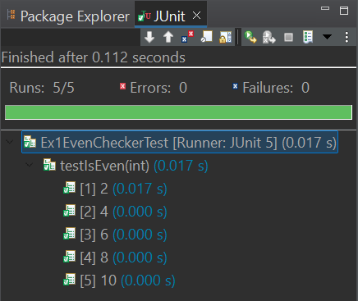

**Exercise 2: Test Suites and Categories**

**Code:**

package week2.module4_2;

import org.junit.jupiter.api.*;

import static org.junit.Assert.*;

import org.junit.platform.suite.api.*;

class TestClass1{

*@Test*

*@Tag*("Tag1")

public void testCase11() {

*assertTrue*(1<2);

}

*@Test*

*@Tag*("Tag2")

public void testCase12() {

*assertTrue*(1<2);

}

}

class TestClass2{

*@Test*

*@Tag*("Tag1")

public void testCase21() {

*assertTrue*(1<2);

}

*@Test*

*@Tag*("Tag2")

public void testCase22() {

*assertTrue*(1<2);

}

}

*@Suite*

*@SelectClasses*({TestClass1.class,TestClass2.class})

*@IncludeTags*("Tag1")

public class Ex2AllTests {

}

**Output:**

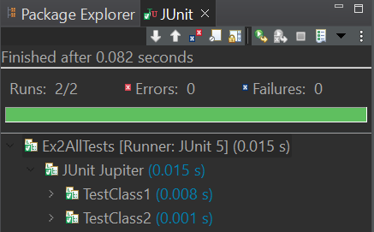

**Exercise 3: Test Execution Order**

**Code:**

package week2.module4_2;

import org.junit.jupiter.api.*;

import static org.junit.Assert.*;

*@TestMethodOrder*(MethodOrderer.OrderAnnotation.class)

public class Ex3TextExecutionOrder {

*@Test*

*@Order*(2)

public void TestCase1() {

System.***out***.println("Test Case 1 Executed");

*assertTrue*(1<2);

}

*@Test*

*@Order*(1)

public void TestCase2() {

System.***out***.println("Test Case 2 Executed");

*assertTrue*(1<2);

}

}

**Output:**

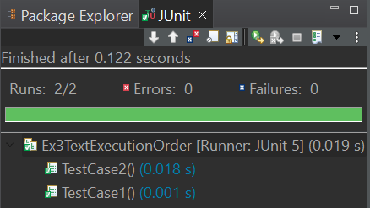



**Exercise 4: Exception Testing**

**Code:**

package week2.module4_2;

import org.junit.jupiter.api.*;

import static org.junit.jupiter.api.Assertions.*;

class ExceptionThrower{

void throwException() throws RuntimeException{

throw new RuntimeException("Exception Thrown");

}

}

public class Ex4ExceptionThrowerTest {

*@Test*

public void testThrowException() {

ExceptionThrower exceptionThrower=new ExceptionThrower();

*assertThrows*(RuntimeException.class,()->{exceptionThrower.throwException();});

}

}

**Output:**

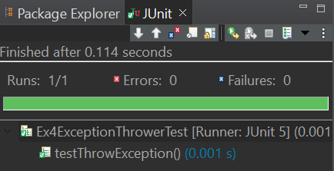

**Exercise 5: Timeout and Performance Testing**

**Code:**

package week2.module4_2;

import org.junit.jupiter.api.*;

import static org.junit.jupiter.api.Assertions.*;

import java.time.Duration;

class PerformanceTester{

void performTask() throws InterruptedException{

Thread.*sleep*(4000);

}

}

public class Ex5PerformanceTesterTest {

PerformanceTester performanceTester=new PerformanceTester();

*@Test*

public void testPerformTask() {

*assertTimeout*(Duration.*ofSeconds*(5),()->performanceTester.performTask());

}

}

**Output:**

